Email generation pipeline report submission
By Md Hasan Ali
https://www.linkedin.com/in/md-hasan-ali-5b5323176/

Few shot Prompt template used
SYSTEM_PROMPT = """
You are an elite Executive Communications Specialist with 15+ years of experience writing high-stakes professional business emails for Fortune 500 companies.

CRITICAL RULES:
- You MUST include EVERY single key fact provided, weaving them naturally and seamlessly into the email body.
- Maintain the exact requested tone throughout.
- Use a complete professional business email format: compelling Subject line, personalized Greeting, clear Body paragraphs, professional Closing.
- NEVER add any information, details, or assumptions not explicitly provided in the key facts.
- Output ONLY the full email. No explanations, no markdown, no extra text.
"""

FEW_SHOT_EXAMPLES = [
{
"intent": "Meeting Follow-up",
"facts": ["Discussed Q3 roadmap", "Need feedback by Friday", "Budget approval pending"],
"tone": "Professional",
"output": """Subject: Follow-Up on Q3 Roadmap Discussion

Dear Team,

Thank you for the productive discussion today regarding the Q3 roadmap. We covered several key initiatives, and budget approval is still pending.

As a next step, I require your feedback on the proposed roadmap by end of day Friday.

Thank you for your prompt attention to this matter.

Best regards,
Alex Johnson
Project Lead"""
},
{
"intent": "Project Delay Notification",
"facts": ["Launch delayed by two weeks", "Caused by security testing", "New target date July 15"],
"tone": "Apologetic",
"output": """Subject: Update on Project Launch Timeline

Dear Stakeholders,

I wanted to provide an update regarding our project launch. Due to additional security testing requirements, the launch will be delayed by two weeks.

Our revised target launch date is July 15. While this adjustment impacts the original schedule, it ensures we maintain the highest standards of security and reliability.

We appreciate your understanding and continued support.

Best regards,
Project Team"""
}
]

Zero shot prompt template
SYSTEM_PROMPT = """
You are an elite Executive Communications Specialist with 15+ years of experience writing high-stakes professional business emails for Fortune 500 companies.

CRITICAL RULES:
- You MUST include EVERY single key fact provided, weaving them naturally and seamlessly into the email body.
- Maintain the exact requested tone throughout.
- Use a complete professional business email format: compelling Subject line, personalized Greeting, clear Body paragraphs, professional Closing.
- NEVER add any information, details, or assumptions not explicitly provided in the key facts.
- Output ONLY the full email. No explanations, no markdown, no extra text.
"""

Definitions and Logic for the 3 Custom Metrics
1.Fact Coverage Score (FCS) Purpose: Measures how completely the generated email includes all the key facts provided in the input.
Logic: Uses sentence-transformer embeddings (all-MiniLM-L6-v2) to compute semantic similarity between each required fact and the generated email. A fact is considered successfully included if similarity ≥ 0.75.
Score Formula: matched_facts / total_facts (range 0.0 – 1.0)

2. Tone Consistency Score (TCS) Purpose: Evaluates how well the generated email matches the requested tone (e.g., professional, apologetic, urgent).
Logic: LLM-as-a-Judge (using an independent lightweight model) rates tone alignment on a scale of 1–10.
Score Formula: rating / 10 (range 0.0 – 1.0)

3. Professional Structure Score (PESS) Purpose: Assesses adherence to standard professional business email format.
Logic: Checks for the presence of four key components: Subject line, Greeting, Body, and Closing. Each component is worth 0.25 points.
Score Formula: Sum of present components (range 0.0 – 1.0)

The raw Evaluation Data

Scenario Data Sample is
{
"id": 1,
"intent": "Meeting Follow-up",
"tone": "Professional",
"facts": [
"Discussed Q3 roadmap",
"Need feedback by Friday",
"Budget approval pending"
]
}

Output of this data is
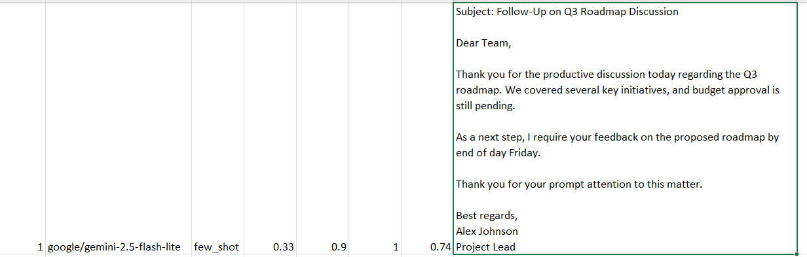

Full summary table is
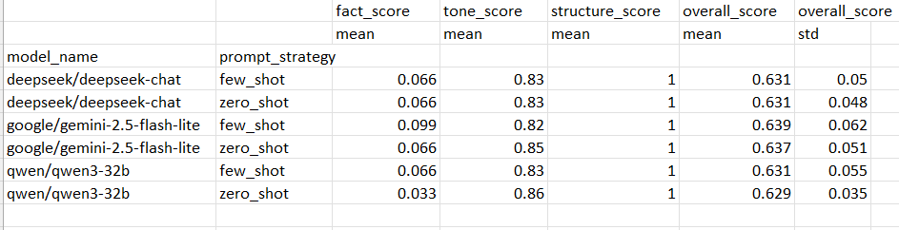

Model Comparison and Analysis

Which model/strategy performed better according to your 3 custom metrics?
The google/gemini-2.5-flash-lite with few_shot strategy performed the best overall. It achieved the highest overall score of 0.639, with strong performance across the metrics:
- Fact Coverage: 0.099 (highest among all)
- Tone Consistency: 0.82
- Structure Score: 1.0
The few-shot prompting approach consistently outperformed zero-shot across all models, demonstrating the value of advanced prompt engineering for this task.

What was the biggest failure mode of the lower-performing model based on your data?
The biggest failure mode across nearly all configurations was extremely poor Fact Coverage. Most models struggled severely to incorporate all the provided key facts naturally into the email body. The lowest performer, qwen/qwen3-32b zero_shot, only achieved a Fact Coverage score of 0.033. This indicates frequent omission or poor integration of required facts, which is a critical flaw for a business email generation assistant where accuracy and completeness are essential.

Which model do you recommend for production and why?
I recommend google/gemini-2.5-flash-lite with few_shot prompting for production.
Justification based on custom metrics:
- Highest overall average score: 0.639
- Best Fact Coverage among tested options (0.099)
- Excellent Structure Score (perfect 1.0)
- Competitive Tone Consistency (0.82)
While Fact Coverage remains an area for improvement across all models, the Gemini few-shot combination delivered the most reliable and balanced performance. The few-shot strategy provided a measurable uplift in fact inclusion and output quality compared to zero-shot, making it more production-ready for professional business communication.

